CE213 Class Problem Sheet 1 (Week 2)

**Introduction to Lab Exercises at Your Own Time (via CE213 Moodle website):**

[**https://moodle.essex.ac.uk/course/view.php?id=3651**](https://moodle.essex.ac.uk/course/view.php?id=3651)

**Lab exercise 1:** at your own time after Week 3,to solve the corn, goose and fox problem by

implementing breath first search in Java.

**Lab exercise 2:** at your own time after Week 4,to create an AI player for the tic-tac-toe board game

by implementing minimax search and alpha-beta pruning algorithm in Java.

**Lab exercise 3:** at your own time after Week 9,to solve the XOR problem or data classification

problem by implementing the error backpropagation learning algorithm for training

a multilayer perceptron (MLP) in Java.

(Q1) Review relevant lecture notes and explain what are meant by the following terms:

i. Lady Lovelace’s Objection

ii. The Turing Test

iii. Searle’s Chinese RoomCE213 Class Problem Sheet 1 (Week 2)

**Introduction to Lab Exercises at Your Own Time (via CE213 Moodle website):**

[**https://moodle.essex.ac.uk/course/view.php?id=3651**](https://moodle.essex.ac.uk/course/view.php?id=3651)

**Lab exercise 1:** at your own time after Week 3,to solve the corn, goose and fox problem by

implementing breath first search in Java.

**Lab exercise 2:** at your own time after Week 4,to create an AI player for the tic-tac-toe board game

by implementing minimax search and alpha-beta pruning algorithm in Java.

**Lab exercise 3:** at your own time after Week 9,to solve the XOR problem or data classification

problem by implementing the error backpropagation learning algorithm for training

a multilayer perceptron (MLP) in Java.

(Q1) Review relevant lecture notes and explain what are meant by the following terms:

i. Lady Lovelace’s Objection

ii. The Turing Test

iii. Searle’s Chinese Room

iv. Weak AI and Strong AI

(Other related terms: artificial general intelligence (AGI), general AI, specialised AI, narrow AI)

(Q2) Multiple choice questions:

(i) Who coined the term ‘artificial intelligence’?

[A] Lady Lovelace

[B] John McCarthy

[C] Alan Turing

[D] Aristotle

(ii) The Turing Test is:

[A]       A proof that artificial intelligence is possible

[B]       A refutation of Lady Lovelace’s Objection

[C]       A criterion that would evaluate whether a machine has achieved weak AI

[D]       All of the above

(iii) Which of the following is true about state space representation of a problem?

[A]       The state space cannot be infinite

[B]       There must be at most one goal state

[C]       There must be more than one operator

[D]       None of the above

(Q3) Assume that in the “three jugs problem” the capacities of the three jugs are 8, 5 and 3 litres respectively, the total amount of liquid available is 8 litres, and the basic volume unit for decanting operation is 1 litre (i.e., always make the destination jug full if possible).

1. Work out how many different states there are in the “three jugs problem”.
2. Find at least one solution to the “three jugs problem” by constructing a search tree with initial state as [8 0 0] and goal state as [4 4 0].

e.g.,

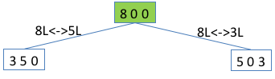

(continue building up the tree till reaching the goal state)

**More questions for homework:**

What are the limitations of the Turing Test?

How would AI impact on the job market in 5~10 years?

How can we stay competitive in the age of AI?

What are the grand challenges in AI?

……

If you are interested, have a look at the Leobner Prize, an annual competition in AI:

In 1990, Hugh Loebner, an American businessman, set up a contest designed to implement the Turing Test (<https://en.wikipedia.org/wiki/Loebner_Prize>).

“A Grand Prize of $100,000 and a Gold Medal will be awarded for the first computer whose responses are indistinguishable from a human's. In addition, each year an annual prize and a bronze medal are awarded to the mosthuman-like computer. The winner of the annual contest is the best entry relative to other entries that year, irrespective of how good it is in an absolute sense.”

Nobody has received the Grand Prize / Gold Medal by now: No program entered for this contest has passed the Turing test!

Is this a useful contribution to the development of artificial intelligence?

Topics: Introduction to AI, state space representation

Answers or hints:

Q1: Find answers from lecture notes.

Q2: (i) B; (ii) C; (iii) D.

Q3:

Let x, y, z be the contents in the 8 litre jug, 5 litre jug and 3 litre jug respectively. They should satisfy the following constraints: 0≤x≤8, 0≤y≤5, 0≤z≤3; x+y+z=8; x,y,z are integers.

There are 9 possible contents of the 8 litre jug: 8,7,6,5,4,3,2,1,0, for each of which we can find out the number of possible contents in the 5 litre jug and 3 litre jug.

There are 24 (=1+2+3+4+4+4+3+2+1) different states as follows:

8,0,0

7,1,0

7,0,1

6,2,0

6,1,1

6,0,2

5,3,0

5,2,1

5,1,2

5,0,3

4,4,0

4,3,1

4,2,2

4,1,3

3,5,0

3,4,1

3,3,2

3,2,3

2,5,1

2,4,2

2,3,3

1,5,2

1,4,3

0,5,3

Removing constraint x+y+z=8: There are 216 (=9x6x4) different states.

Removing constraint that x, y, z are integers: There could be infinite states.

Search tree (incomplete):

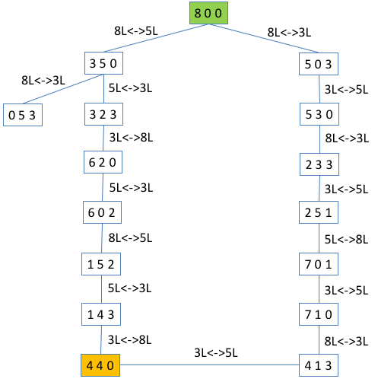

**More questions for homework:**

The Turing Test involves natural language processing tasks only. The expert panel (interrogators/judges) may be biased. The human player/actor may not be selected appropriately. It is not valid for assessing strong AI as it is based on a behavioural argument. It may not be the best criterion/approach for evaluating AI.

(What would you suggest as a better test for assessing AI?)

New jobs created due to advances in AI...

Jobs that may disappear due to AI…

Think about what challenges are in developing self-driving cars, personal service robots, AI for health-care, etc.

CE213 Class Problem Sheet 2 (Week 3)

**Assignment Briefing:** [**https://moodle.essex.ac.uk/course/view.php?id=3651**](https://moodle.essex.ac.uk/course/view.php?id=3651)

|  |  |  |
| --- | --- | --- |
| 8 | 7 | 6 |
| 5 | 4 | 3 |
| 2 | 1 |  |

|  |  |  |
| --- | --- | --- |
| 8 | 7 | 6 |
| 5 | 4 | 3 |
| 2 |  | 1 |

|  |  |  |
| --- | --- | --- |
| 8 | 7 | 6 |
| 5 | 4 |  |
| 2 | 1 | 3 |

…… ……

|  |  |  |
| --- | --- | --- |
| 1 | 2 | 3 |
| 4 | 5 | 6 |
| 7 | 8 |  |

(Goal configuration)

How to represent the 8-puzzle problem as state space?

Which node to expand next?

* Which node is closer to the goal configuration? – Need heuristics!

How to expand? – There could be 2, 3, or 4 possible tile moves, depending on the location of the empty square.

(Q1) Which of the following statements is true about depth first search?

[A] It expands the least recently generated node.

[B] It expands the most recently generated node.

[C] It expands the node that has been reached at lowest cost.

[D] It expands the node that is closest to the goal state.

(Q2) The diagram below shows six towns: A, B, C, D, E and F. The numbers alongside the lines indicate the lengths of the roads between the towns.

20

35

40

40

45

30

B

E

D

**A** are asked to find a short route from A to F. Using these rough estimates to evaluate alternative route choices, determine the route you would select if you employed a *hill-climbing* strategy. Calculate the length of this route.A

**F**

C

20

The table below provides rough estimates of the length of the shortest distance from each town to town F.

|  |  |
| --- | --- |
| Town | Distance from F |
| A | 80 |
| B | 60 |
| C | 27 |
| D | 50 |
| E | 30 |
| F | 0 |

You are asked to find a good route from A to F. Using these rough estimates as a heuristic, determine the route you would select if you adopt *A* search*.

(i) List the nodes that would be expanded in the order in which they would be

chosen for expansion.

(ii) State the route that would be found using this method.

(iii) State the length of this route.

State the route that would have been found if you had used:

(iv) Greedy search

(v) Uniform cost search

Has A* search found an optimal solution? Why?

If unform cost search checks whether a generated node is goal state immediately after it is generated and stops search as soon as a goal state is reached, will uniform cost search find optimal solution in this case?

N.B. Based on this question, some multiple choice questions could be designed.

e.g., during the uniform cost search,how many of the 6 nodes will not be selected for expansion?

[A] 0

[B] 1

[C] 2

[D] 3

If ‘during uniform cost search’ is replaced by ‘during A* search’, will the answer be the same?

Topics: Blind search and heuristic search

Answers or hints:

Q1: B (A. BFS; B. DFS; C. Uniform cost search; D. Greedy search)

Q2: Follow the similar search procedures as described in the lecture notes, as illustrated below:

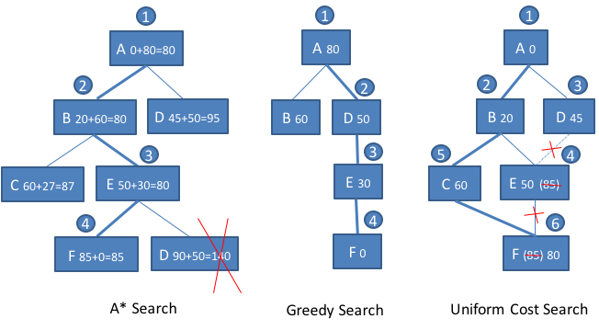

Answers:

1. A, B, E, F
2. A->B->E->F
3. 20+30+35=85
4. A->D->E->F
5. A->B->C->F

A* search has not found an optimal solution to this problem, because the heuristic is not admissible: The estimated shortest distance between C and F is 27 in the table, whilst the actual distance between C and F is 20 only. Therefore, the heuristic overestimates the cost, and thus is not admissible. If we change the estimated distance between C and F to 19, then the heuristic is admissible, and A* search will find the optimal route.

If unform cost search checks whether a generated node is goal state immediately after it is generated and stops search as soon as a goal state is reached, then it will not find optimal solution in this case.

Play the PPT slides on the CE213 Moodle to see the search tree construction procedure by A* search and uniform cost search respectively.

Answers for the multiple choice questions: [A] (if uniform cost search); [C] (if A* search).

CE213 Class Problem Sheet 3 (Week 4)

Mock paper for Progress Test 1 in Week 6 (on Moodle). Questions about progress test?

(Q1) The diagram below shows a game tree in a two-player board game, in which it is Player One’s turn to make a move. Assume an evaluation function is available that returns an estimate of the value of a position (a node) to Player One and the numbers in the leaf nodes show the results of applying this function to the corresponding board positions. Player One has a choice of three moves: A, B or C. Use the minimax search strategy to determine the best move and state the value that is backed up to the root node.

6

17

11

8

7

9

19

5

12

Move A

Move B

Move C

(Q2) Assume that nodes are considered from left to right. If alpha-beta pruning is used in applying the minimax procedure, which leaf nodes need not be evaluated?

(Q3) Which leaf nodes need not be evaluated using alpha-beta pruning if nodes are considered from right to left.

(Q4) The diagram below shows a game tree in a two-player board game, in which it is Player One’s turn to make a move and the numbers under the leaf nodes show their values (just assume these values are obtained from some heuristics) to Player One. Assume that nodes are considered from left to right. If alpha-beta pruning is used in applying the minimax procedure to this game tree, what would be the value returned to node A and which nodes (including non-leaf nodes) need not be considered for evaluation?

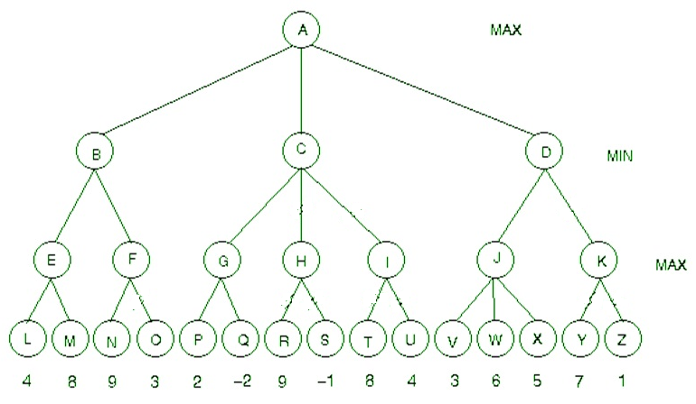

**More questions (could be for homework):**

1. Will minimax search with alpha-beta pruning return the same value to the root node (current game position) as that returned by minimax search without alpha-beta pruning?

2. How to evaluate game positions for minimax search that doesn’t backtrack from endgame positions?

(e.g., for the 5x5 Tic-Tac-Toe game, backtracking from endgame positions would be too slow)

Topics: minimax search, alpha-beta pruning

Answers or hints:

Q1:

7

6

6

17

11

7

8

7

9

5

19

5

12

Move A

Move B

Move C

Best move: B, value: 7

Q2:

7

6

6

17

11

7

8

7

9

5

?

5

12

Move A

Move B

Move C

The node marked with ? needs not be evaluated.

Q3:

7

6

6

?

?

7

8

7

9

5

19

5

12

Move A

Move B

Move C

The nodes marked with ? need not be evaluated.

Q4: The value returned to node A is 8, as indicated below. The nodes H, I, K, O, R, S, T, U, Y, Z need not be considered for evaluation.

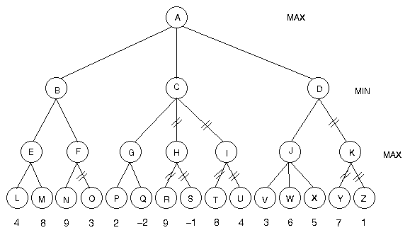

8

6

6

2

2

8

9

8

By using alpha-beta pruning in this example over 1/3 of the nodes can be ignored in the minimax search.

**More questions:**

Yes. Minimax search with or without alpha-beta pruning will return the same value to root node. Alpha-beta pruning only improves the speed of minimax search.

For the 5x5 Tic-Tac-Toe game, a simple game position evaluation function could be defined as follows (may not be the best):

There are 12 possible win situations: 5 horizontal lines, 5 vertical lines, 2 diagonal lines, with the whole line occupied by one player only.

*Assume the AI player is ‘X’*.

If a line has both ‘X’ and ‘O’, the value of this line to AI player is 0.

If a line has n ‘X’s, but no ‘O’, the value of this line to AI player is 10n, e.g., 10 (n=1), 10000 (n=4).

If a line has n ‘O’s, but no ‘X’, the value of this line to AI player is -10n, e.g., -10 (n=1), -10000 (n=4).

The value of a game position to AI player can be defined as the sum of values of the 12 lines to AI player.

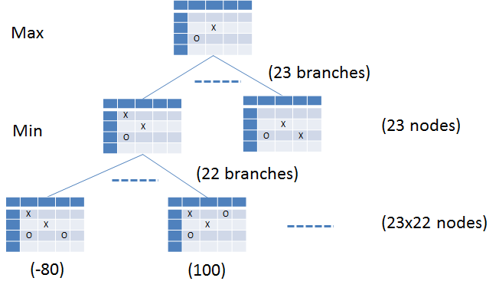**Examples of non-endgame positions:**

|  |  |  |  |  |
| --- | --- | --- | --- | --- |
|  |  |  |  |  |
|  |  |  |  |  |
|  |  | O |  |  |
|  | X |  |  |  |
|  |  |  |  |  |

The value to AI player is 10+10-10-10-10 = -10

|  |  |  |  |  |
| --- | --- | --- | --- | --- |
|  |  |  |  |  |
|  |  |  |  |  |
|  |  | X |  |  |
|  | O |  |  |  |
|  |  |  |  |  |

The value to AI player is 10+10+10-10-10 = 10

|  |  |  |  |  |
| --- | --- | --- | --- | --- |
|  |  |  |  |  |
|  | X |  |  |  |
|  |  | X |  |  |
|  | O |  | O |  |
|  |  |  |  |  |

The value to AI player is 10+10+10-100-10 = -80

|  |  |  |  |  |
| --- | --- | --- | --- | --- |
|  |  |  |  |  |
|  | X |  | O |  |
|  |  | X |  |  |
|  | O |  |  |  |
|  |  |  |  |  |

The value to AI player is 100+10+10-10-10 = 100

|  |  |  |  |  |
| --- | --- | --- | --- | --- |
|  |  |  |  |  |
|  | X |  | O |  |
|  |  | X |  |  |
|  | O | X | O |  |
|  |  |  |  |  |

The value to AI player is 100+10-100 = 10

**Examples of endgame positions:**

|  |  |  |  |  |
| --- | --- | --- | --- | --- |
| X | O | X | O | O |
| O | X | X | O | X |
| O | X | X | O | X |
| O | O | X | O | X |
| X | O | X | X | O |

‘win’ endgame, its value to Player ‘X’ is +105 or just some positive number

|  |  |  |  |  |
| --- | --- | --- | --- | --- |
| X | O | X | O | O |
| O | X | X | O | X |
| O | X | X | O | X |
| O | O | X | O | X |
| X | X | O | O | O |

‘loss’ endgame, its value to Player ‘X’ is -105 or just some negative number

|  |  |  |  |  |
| --- | --- | --- | --- | --- |
| O | O | X | O | O |
| O | X | X | O | X |
| O | X | X | X | X |
| O | O | X | O | X |
| X | X | O | O | O |

‘draw’ endgame, its value to Player ‘X’ is 0

CE213 Class Problem Sheet 4 (Week 5)

**A short Q&A session for any questions about assignment, progress test, and lectures: …**

**MCQ used in polls in lectures:**

3-11-2020

Which of the following statements is true?

[A] Minimax search does not use heuristics to evaluate non-leaf nodes in the game tree.

[B] Alpha-beta pruning can speed up minimax search but will not influence the value returned to the root node by minimax search.

[C] In minimax search no criteria for node selection are required for node expansion in the process of game tree construction, whilst Monte-Carlo tree search does node selection for node expansion in the process of game tree construction.

[D] All of the above

(Answer: D)

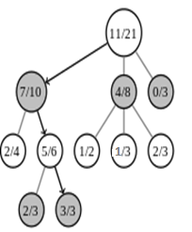(Q1) The diagram below shows a game tree, with the number within each node representing the ratio of number of wins to number of visits. Justify that the node with the win ratio of 3/3 should be selected for expansion next using the following upper confidence bound as exploration-exploitation trade-off:



*wi* : no. of wins after visiting node *i*

*ni* : no. of times node *i* has been visited.

*t* : no. of times the parent of node *i* has been visited.

[The result has been presented in the lecture.

This exercise is to ensure you know how to

calculate UCB and how to use UCB values to

select a node for expansion.]

(Q2) The following set of rules forms a simple production system:

Rule 1: IF waffleshaft is grimped

THEN CONCLUDE grudline is thwarted

Rule 2: IF ascerbic index exceeds 10

THEN CONCLUDE remedy is hyposubduction

Rule 3: IF ascerbic index exceeds 5

THEN CONCLUDE spriggot is frenetic

Rule 4: IF grudline is thwarted

AND detractor is active

THEN CONCLUDE remedy is dephlogistination

Rule 5: IF quadrenometer indicates surfeit

THEN CONCLUDE detractor is active

Rule 6: IF euphoria is falling

THEN CONCLUDE detractor is active

Initially, the following four facts are loaded into working memory:

The waffleshaft is grimped

The ascerbic index is 7

The quadrenometer indicates no surfeit

Euphoria is falling

1. A *forward chaining interpreter* uses recency as its main conflict resolution strategy and any remaining conflicts are resolved by choosing the first matched rule in the list. Trivial loops are prevented by refractoriness. Assume the above four facts have the same recency. Describe the sequence of operations (rule firing) that will take place in order to find a remedy. List all the facts that will be in working memory when execution stops.
2. Describe the sequence of operations (rule firing) that will take place if the set of rules is interpreted by an *exhaustive* *backward chaining interpreter* given the goal of finding a remedy. List all the facts that will be in working memory when execution stops.

[N.B. This production system may be meaningless, but it is good for practicing production rule interpretation and for demonstrating the effect of conflict resolution.]

**More questions (could be for homework):**

1. How are game positions evaluated in minimax search and Monte-Carlo tree search respectively?

2. What problems are more suitable to be solved by expert systems rather than state space search?

3. What are the main differences between forward chaining and backward chaining?

4. What problems/tasks are more suitable to be solved by forward chaining interpreters?

5. What problems/tasks are more suitable to be solved by backward chaining interpreters?

Topics: game playing (MCTS), forward chaining, backward chaining

Answers:

Q1: The UCB values of the nodes are calculated and indicated in the figure below. It can be seen that the node with the win ratio of 3/3 has the highest UCB value and its parent node and parent’s parent node also have larger UCB values. Therefore, it should be selected for expansion next [There are two ways to select: 1. Select the child node of the root node, which has the largest UCB value, then select the child node of the previously selected node, which has the largest UCB value, and repeat this until a leaf node is selected. 2. Select the node that has the largest UCB value among the unexpanded nodes. The second way is simpler, but may not work well for some game trees.]

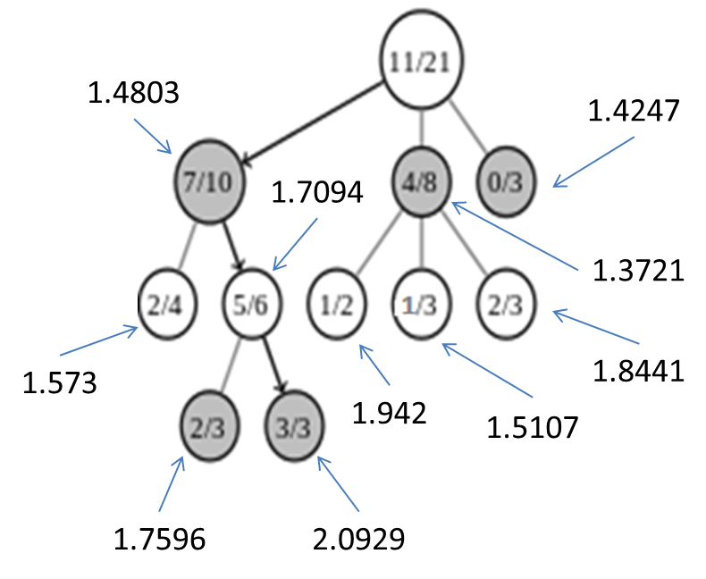

e.g., for node with win ratio 7/10: UCB=7/10+sqr(2)*sqr[ln(21)/10]=1.4803…

Q2:

(i)

1. Assuming the initial four facts have the same recency:

sequence of operations:

1st match-execute cycle: Rule 1 fires, adding grudline is thwarted to working memory

2nd match-execute cycle: Rule 3 fires, adding spriggot is frenetic to working memory

3rd match-execute cycle: Rule 6 fires, adding detractor is active to working memory

4th match-execute cycle: Rule 4 fires, adding remedy is dephlogistination to working memory

All the facts in working memory when execution stops:

The waffleshaft is grimped

The ascerbic index is 7

The quadrenometer indicates no surfeit

Euphoria is falling

Grudline is thwarted

Spriggot is frenetic

Detractor is active

Remedy is dephlogistination

1. Assuming ‘Euphoria is falling’ is the most recent fact and ‘waffleshaft is grimped’ the least recent fact among the four initial facts:

sequence of operations:

1st match-execute cycle: Rule 6 fires, adding detractor is active to working memory

2nd match-execute cycle: Rule 3 fires, adding spriggot is frenetic to working memory

3rd match-execute cycle: Rule 1 fires, adding grudline is thwarted to working memory

4th match-execute cycle: Rule 4 fires, adding remedy is dephlogistination to working memory

All the facts in working memory when execution stops:

The waffleshaft is grimped

The ascerbic index is 7

The quadrenometer indicates no surfeit

Euphoria is falling

Detractor is active

Spriggot is frenetic

Grudline is thwarted

Remedy is dephlogistination

(ii)

Sequence of hypothesis testing:

Initial hypothesis: remedy is X

Rule 2: LHS fails

Rule 4: LHS not sure

Subsidiary hypothesis: grudline is thwarted

Rule 1: LHS satisfied. **Add grudline is thwarted to working memory.**

Subsidiary hypothesis: detractor is active

Rule 5: LHS fails

Rule 6: LHS satisfied. **Add detractor is active to working memory**.

Rule 4: LHS satisfied. **Add remedy is dephlogistination to working memory**.

Sequence of operations:

Rule 1, Rule 6, and Rule 4 will fire in turn.

All the facts that will be in working memory when execution stops:

The waffleshaft is grimped

The ascerbic index is 7

The quadrenometer indicates no surfeit

Euphoria is falling

Grudline is thwarted

Detractor is active

Remedy is dephlogistination

*[In comparison with forward chaining, backward chaining doesn’t need conflict resolution and usually uses less working memory (e.g., rule 3 has not fired).]*

**More questions (could be for homework):**

1. Minimax search: Evaluate endgame positions first if possible and then backtrack their values to the current game position by alternative minimising and maximising steps. If endgame positions are too deep to be backtracked within reasonable time, evaluate game positions at certain depth using some heuristics and then backtrack their values to the current game position by alternative minimising and maximising steps.

MCTS: A large number of iterations of ‘(node) selection, (node) expansion, simulation, and backpropagation’ are executed. In each iteration, a simulated game is played with random moves from the selected leaf node to endgame, and based on the outcome of the simulated game (win, loss, or draw) the win ratios (values) of the game positions corresponding to the nodes on the path of backtracking from the selected leaf node to the root node are updated.

2. Problems whose solutions cannot be represented as a sequence of state transitions, or in which state transitions are difficult to define and states are difficult to evaluate. Examples include medical diagnosis and financial market prediction.

3.

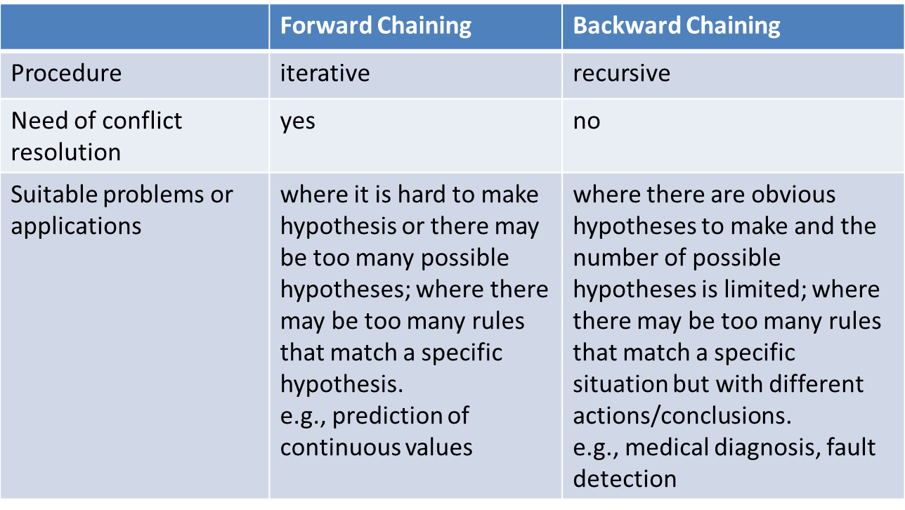

4. Problems in which it is difficult to form a hypothesis, such as prediction of the value of a continuous variable.

5. Problems with a small number of clear possible hypotheses that could be created and whose facts may match a large number of rules, such as medical diagnosis.

CE213 Class Problem Sheet 5 (Week 7)

(Q1) Determine the logarithm to base 2 of each of the following: 2; 8; 1; 0.5; 0.25; 0.125

(Q2) Suppose the probabilities of tomorrow’s temperature are as follows

P(Warm) = 0.25

P(Cool) = 0.5

P(Freezing) = 0.25

How much information will you receive when you discover tomorrow’s temperature?

[This type of questions can be easily changed to multiple choice questions for progress test]

(Q3) Suppose you are told:

Probability of someone who has a cold suffering from sneezing is 0.9.

Probability of someone who has hay fever suffering from sneezing is 0.8.

Proportion of population with a cold at a given time is 2%.

Proportion of population with hay fever at a given time is 4%.

Proportion of population suffering from sneezing at a given time is 6%.

Assuming that nobody ever has hay fever and a cold at the same time, on the basis of this data determine the probability that a person who is sneezing:

i. has a cold

ii. has hay fever

[Just for fun you may guess before you find the answer which conditional probability is higher.]

(Q4) The following data are used to train a system to determine the best crop to grow in a particular field (given drainage, soil, and PH):

|  |  |  |  |
| --- | --- | --- | --- |
| *Drainage* | *Soil* | *PH* | *Best Crop* |
| Good | Heavy | Acid | Thistles |
| Poor | Heavy | Acid | Dandelions |
| Poor | Light | Acid | Bindweed |
| Good | Light | Alkaline | Thistles |
| Good | Heavy | Alkaline | Thistles |
| Poor | Heavy | Alkaline | Dandelions |
| Good | Light | Acid | Thistles |
| Poor | Light | Alkaline | Bindweed |

1. Calculate the information gains provided by each of the three attributes: Drainage, Soil and PH.
2. Construct the decision tree for determining the best crop from the values of these three attributes.
3. Convert the decision tree into a production system, i.e., a set of IF_THEN rules.

[ log2(1/2)=-1, log2(1/4)=-2, log2(1/8)=-3 ]

Topics: Logarithm, probability, information, information gain, and decision tree induction

Answers or hints:

Q1: 1, 3, 0, -1, -2, -3

Q2: Information = -sum{i=1 to N}(pilog2(pi)) = -0.25xlog2(0.25)-0.5xlog2(0.5)-0.25xlog2(0.25) = 1.5

Q3: P(cold)=0.02, P(hay fever)=0.04, P(sneezing)=0.06,

P(sneezing | cold)=0.9, P(sneezing | hay fever)=0.8.

Based on the Bayes theorem, we have

P(cold | sneezing)= P(sneezing | cold)*P(cold)/P(sneezing)=0.9*0.02/0.06=0.3

P(hay fever | sneezing)= P(sneezing | hay fever)*P(hay fever)/P(sneezing)=0.8*0.04/0.06=0.53

Q4:

***Initial information about Best Crop:***

Inf=-(2/8)*log2(2/8) –( 2/8)*log2(2/8) –( 4/8)*log2(4/8))=1.5 bits

***Information gain from Drainage:***

P(Drainage=good)=P(Drainage=poor)=0.5

P(Bindweed | good)=0, P(Dandelions | good)=0, P(Thistles | good)=4/4

P(Bindweed | poor)=2/4, P(Dandelions | poor)=2/4, P(Thistles | poor)=0

Inf_good=-0-0-(4/4)*log2(4/4)=0

Inf_poor=-(2/4)*log2(2/4) -(2/4)*log2(2/4)-0=1

Average information about best crop given Drainage=0.5×0+0.5×1=0.5

Information gain from Drainage=1.5-0.5=1

***Information gain from Soil:***

P(Soil=heavy)=P(Soil=light)=0.5

P(Bindweed | heavy)=0, P(Dandelions | heavy)=2/4, P(Thistles | heavy)=2/4

P(Bindweed | light)=2/4, P(Dandelions | light)=0, P(Thistles | light)=2/4

Inf_heavy=-0-(2/4)*log2(2/4) -(2/4)*log2(2/4)=1

Inf_light=-(2/4)*log2(2/4) -0-(2/4)*log2(2/4)=1

Average information about best crop given Soil=0.5×1+0.5×1=1

Information gain from Soil=1.5-1=0.5

***Information gain from PH:***

P(PH=acid)=P(PH=Alkaline)=0.5

P(Bindweed | acid)=1/4, P(Dandelions | acid)=1/4, P(Thistles | acid)=2/4

P(Bindweed | alkaline)=1/4, P(Dandelions | alkaline)=1/4, P(Thistles | alkaline)=2/4

Inf_acid=-(1/4)*log2(1/4) -(1/4)*log2(1/4) - (2/4)*log2(2/4))=1.5

Inf_alkaline=-(1/4)*log2(1/4) - (1/4)*log2(1/4) - (2/4)*log2(2/4))=1.5

Average information about best crop given PH=0.5×1.5+0.5×1.5=1.5

Information gain from PH=1.5-1.5=0

Best attribute is Drainage. It is the root node of the decision tree.

For the ‘good’ branch, all samples are from ‘Thistles’ class, leading to a leaf node labelled as ‘Thistles’.

For the ‘poor’ branch, there are 4 samples: 2 from ‘Bindweed’ class and 2 from ‘Dandelions’ class. Calculate information gains from the remaining attributes Soil and HP. Soil is the best attribute now and is used as the node for further extension.

For the ‘heavy’ branch, all samples are from ‘Dandelions’ class, leading to a leaf node labelled as ‘Dandelions’.

For the ‘light’ branch, all samples are from ‘Bindweed’ class, leading to a leaf node labelled as ‘Bindweed’.

***Decision tree: Production system:***



IF Drainage is good

THEN CONCLUDE Best crop is Thistles

IF Drainage is poor AND Soil is heavy

THEN CONCLUDE Best crop is Dandelions

IF Drainage is poor AND Soil is light

THEN CONCLUDE Best crop is Bindweed

CE213 Class Problem Sheet 6 (Week 8)

**Poll used in the lecture on 24-11-2020:**

Which of the following statements is **not true**?

[A] Knowledge representation in a decision tree is similar to that in a production system.

[B] Decision tree induction is a parametric learning process.

[C] It is possible that a decision tree constructed through decision tree induction may not classify some training samples correctly.

[D] Information defined by the Shannon's information formula cannot be negative.

(Q1) An exhaustive backward-chaining expert system uses Mycin’s certainty factor system for reasoning with uncertainty. It includes the following rules.

R1: IF the warning light is flashing red

THEN CONCLUDE an explosion is imminent WITH CERTAINTY 0.99

R2: IF the machine has overheated

AND a valve has fractured

THEN CONCLUDE an explosion is imminent WITH CERTAINTY 0.7

R3: IF the warning light is flashing yellow

THEN CONCLUDE a valve has fractured WITH CERTAINTY 0.6

R4: IF smoke is coming out of the vents

THEN CONCLUDE the machine has overheated WITH CERTAINTY 0.9

R5: IF smoke is coming out of the vents

OR the warning light is flashing blue

THEN CONCLUDE a valve has fractured WITH CERTAINTY 0.5

Given that the warning light is definitely flashing yellow and smoke is definitely coming out of the vents, indicate which rules will fire if the system is asked to determine the certainty that an explosion is imminent. List all the facts that will be in working memory and the certainties with which they will be believed.

(Q2) Devise a McCulloch-Pitts neuron that will compute the binary boolean function NAND.

(Q3) Devise a McCulloch-Pitts neuron that will classify the flower samples given in the following figure correctly (x1 and x2 are shape features of the flowers): The neuron’s output is 1 for virginica samples and 0 for versicolor samples. (The number of possible solutions is infinite. Choose one that you think is a good solution.)

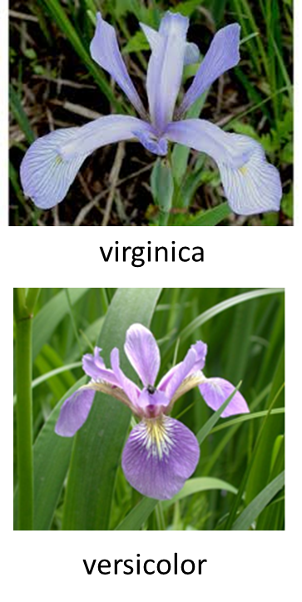

Topics: Reasoning with uncertainty, MP neuron and neural network

Answers or hints:

Poll: B

Q1:

Sequence of hypothesis testing:

Initial hypothesis: an explosion is imminent

Rule 1: LHS fails.

Rule 2: LHS not sure.

Subsidiary hypothesis: the machine has overheated

Rule 4: LHS satisfied. **Add the machine has overheated with certainty 1x0.9=0.9 to working memory.**

Subsidiary hypothesis: a valve has fractured

Rule 3: LHS satisfied. Conclude a valve has fractured with certainty 1x0.6=0.6

Rule 5: LHS satisfied. Conclude a valve has fractured with certainty 1x0.5=0.5

Combined certainty: 0.5+(1-0.5)x0.6=0.8

**Add a valve has fractured with certainty 0.8 to working memory.**

Rule 2: LHS satisfied with certainty min{0.8, 0.9}=0.8. **Add an explosion is imminent with certainty 0.8x0.7=0.56 to working memory.**

Sequence of operations:

Rule 4, Rule 3, Rule 5, and Rule 2 will fire in turn.

All the facts that will be in working memory and their certainties are as follows:

The warning light is flashing yellow, 1.0

Smoke is coming out of the vents, 1.0

The machine has overheated, 0.9

A valve has fractured, 0.8

An explosion is imminent, 0.56

Q2: Solve equations based on a truth table or use graphic interpretation.

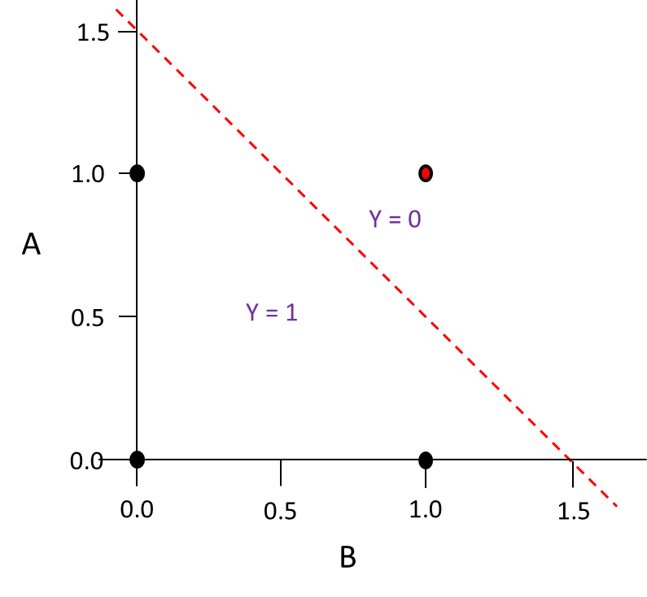NAND

θ/wA

0>θ (for A=0, B=0, Y=1)

wAA + wBB = θ

WA>θ (for A=1, B=0, Y=1)

WB>θ (for A=0, B=1, Y=1)

WA+ WB <θ (for A=1, B=1, Y=0)

A typical solution:

WA=-1, WB=-1, θ=-1.5

(The number of possible

solutions is infinite.)

θ/wB

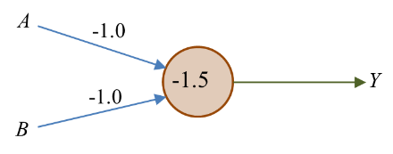

Q3: Let the MP neuron’s weights and threshold be w1, w2, and θ respectively. One possible design is to make w1x1 + w2x2 - θ = 0 represent the blue line in the following figure, which results in =5.5 (intercept on x1 axis) and θ/w2=2.5 (intercept on x2 axis). Hence, a possible design could be θ=5, w1=5/5.5=0.9, w2=5/2.5=2. The number of possible solutions is infinite. A good solution is the one with the separation line away from the samples, as far as possible.



w1x1 + w2x2 - θ = 0

θ/w1

θ/w2

CE213 Class Problem Sheet 7 (Week 9)

(Q1) An example question of Progress Test 2:

A system is monitored by two sensors, and the two sensor readings *S1*and *S2* are used as the inputs of the following MP neuron.



If the neuron's output *Y*=1, then the system is faulty. Which of the following situations indicates that the system is faulty?

[A] S1=1.8, S2=0.0

[B] S1=0.0, S2=2.1

[C] S1=1.0, S2=1.0

[D] All of the above

(Q2) Calculate the output Y of the following McCulloch-Pitts neural network of 3 MP neurons when its inputs are S1=1 and S2=1.

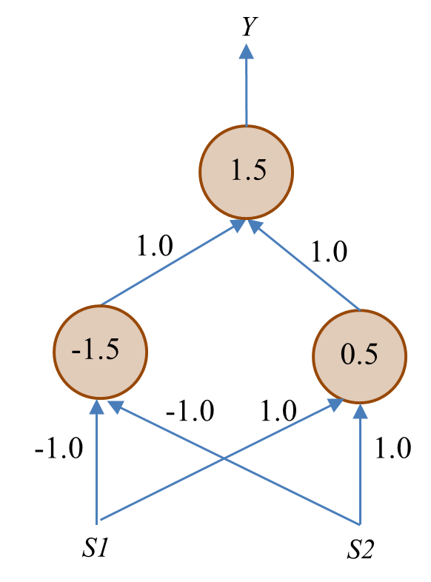

(Q3) The following table lists several attributes of five animals:

|  |  |  |  |  |  |
| --- | --- | --- | --- | --- | --- |
|  | **Dangerous?** | **Zoo Animal?** | **Stripes?** | **Four Legs?** | **Aquatic?** |
| **Bear** | Yes | Yes | No | Yes | No |
| **Tiger** | Yes | Yes | Yes | Yes | No |
| **Dog** | No | No | No | Yes | No |
| **Giant Squid** | Yes | No | No | No | Yes |
| **Cat** | No | No | No | Yes | No |

The **similarity of two animals** is defined as the number of attribute values they have in common. The **similarity of two groups of animals** is defined as the similarity of the most similar pair of animals where each member of the pair is from a different group. Draw the dendrogram that would be produced using the *agglomerative hierarchical clustering* technique.

(Hint: You will probably find it helpful to begin by drawing up a table showing the similarities between each pair of animals).

(Q4) **(This is an optional question, which may be difficult to most students.)**

A neural network consists of 1 output neuron, 2 hidden neurons, and 3 inputs. The neuron’s activation function is a logistic function, i.e.,  and . Derive the rule/equation for updating the weight between the 1st hidden neuron and the 1st input according to the generalised delta learning rule.

**More questions (could be for homework):**

1. What is the difference between a machine learning model and a machine learning algorithm?

2. What is structural learning? Give an example of structural learning.

3. Describe the knowledge representation methods you have learnt so far.

Topics: Neural networks and clustering

Answers or hints:

Q1: D

Q2:

When S1=1, S2=1: the input to the neuron with a threshold of -1.5 is -1x1-1x1=-2<-1.5, and thus the output of this neuron is 0; the input to the neuron with a threshold of 0.5 is 1x1+1x1=2>0.5, and thus the output of this neuron is 1; the input to the output neuron is 1x0+1x1=1<1.5, and thus the output of the output neuron is 0.

Q3:

Animal pairs Similarities

Bear & Tiger 4

Bear & Dog 3

Bear & Giant Squid 2

Bear & Cat 3

Tiger & Dog 2

Tiger & Giant Squid 1

Tiger & Cat 2

Dog & Giant Squid 2

Dog & Cat 5

Giant Squid & Cat 2



(Is this dendrogram sensible to you?)

Q4:

Let the neural network’s input-output relationship be



According to the generalised delta rule we have



(You may also derive this using the equations on slide 12 for lecture 15. Set *yk* to *y* as there is one output neuron only.)

**More questions:**

1. A machine learning model is a problem solver such as a decision tree or neural network. A machine learning algorithm is for optimising models for solving problems.

2. Structuring learning is a type of machine learning that optimises/determines the structure of a model for problem solving. Decision tree induction is an example of structural learning.

3. In expert systems, knowledge is represented as IF-THEN rules. Decision tree itself represents knowledge discovered by machine learning from data. In neural networks, knowledge is represented in connections weights and neuronal biases in a distributed manner.

CE213 Class Problem Sheet 8 (Week 10)

(Q1) In the following state transition diagram, the number alongside each arrow indicates the reward associated with that transition.

(a) Calculate the maximum discounted cumulative reward of each state if the discount factor is 0.5. Find the optimal control policy from E to G based on the calculated discounted cumulative reward values.

(b) Calculate the Q values for the transitions from state E to state G by following the Q learning algorithm for 2 iterations. For simplicity, assume in both iterations the actions selected in state E, B and NG are To-B, To-NG and To-G, respectively (Different action selections will lead to different Q learning results).

##### D

E

##### B

#### **A**

0

**C**

100

60

NG

G

**Discussions:**

Machine learning models you have learnt in this module:

Machine learning algorithms you have learnt in this module:

Three fundamental approaches to artificial intelligence:

…..

Topics: Reinforcement Learning

Answers:

Q1:

1. Discounted cumulative reward . The maximum *V* value for each state is shown below. (N.B. There may be more than one route to G from each state, with different *V* values. For example, the second highest *V* value for state C is 50.)

##### D

**50**

E

55

##### B

**110**

#### **A**

**100**

0

**C**

**55**

100

60

NG

100

G

0

Optimal control policy from E to G based on the discounted cumulative reward values: E -> B -> NG -> G

1. The Q values for the transitions from state E to state G are calculated by following the Q learning algorithm:

*QE(s,a) := rE(s,a) + γ × maxa′ QE(s′,a′)*

*rE(s,a) := QE(s,a)*

and assuming that actions selected in state E, B and NG are To-B, To-NG and To-G, respectively (The learning results will depend on actions chosen at each state):

Set all the initial QE (Q estimation) to 0 (for simplicity, ignore the states that are not in the selected route): QE(E, a)=0, QE(B, a)=0, QE(NG, a)=0, QE(G, a )=0.

Given rE(E, to-B)=0 (another possible action is to-C), rE(B, to-NG)=60, rE(NG, to-G)=100.

Update QE and rE (first iteration):

**QE(E, to-B)=rE(E, to-B)+0.5xQE(B, a)=0+0.5x0=0** (another possible action is to-C)

**QE(B, to-NG)=rE(B, to-NG)+0.5xQE(NG, a)=60+0.5x0=60** (other possible actions are to-C and to-E)

**QE(NG, to-G)=rE(NG, to-G)+0.5xQE(G, a)=100+0.5x0=100** (only one action available)

**QE(G, a )=0** (no action available at G)

**rE(E, to-B)=QE(E, to-B)=0, rE(B, to-NG)=QE(B, to-NG)=60,**

**rE(NG, to-G)=QE(NG, to-G)=100.**

No action available at G, Start again.

Update QE and rE (second iteration):

**QE(E, to-B)= rE(E, to-B)+05xQE(B, a)=0+0.5x60=30**

**QE(B, to-NG)= rE(B, to-NG)+0.5xQE(NG, a)=60+0.5x100=110**

**QE(NG, to-G)= rE(NG, to-G)+0.5xQE(G, a)=100+0.5x0=100**

**QE(G, a )=0** (no action available at G)

**rE(E, to-B)=QE(E, to-B)=30, rE(B, to-NG)=QE(B, to-NG)=110,**

**rE(NG, to-G)=QE(NG, to-G)=100**

No action available at G, Start again.

….

The QE values will be improved with the Q learning process.

When to stop the Q learning? – Have reached a preset max number of iterations or no improvement can be achieved any more.

**CE213-5-AU**

**END OF PAPER CE213-5-AU**

iv. Weak AI and Strong AI

(Other related terms: artificial general intelligence (AGI), general AI, specialised AI, narrow AI)

(Q2) Multiple choice questions:

(i) Who coined the term ‘artificial intelligence’?

[A] Lady Lovelace

[B] John McCarthy

[C] Alan Turing

[D] Aristotle

(ii) The Turing Test is:

[A]       A proof that artificial intelligence is possible

[B]       A refutation of Lady Lovelace’s Objection

[C]       A criterion that would evaluate whether a machine has achieved weak AI

[D]       All of the above

(iii) Which of the following is true about state space representation of a problem?

[A]       The state space cannot be infinite

[B]       There must be at most one goal state

[C]       There must be more than one operator

[D]       None of the above

(Q3) Assume that in the “three jugs problem” the capacities of the three jugs are 8, 5 and 3 litres respectively, the total amount of liquid available is 8 litres, and the basic volume unit for decanting operation is 1 litre (i.e., always make the destination jug full if possible).

1. Work out how many different states there are in the “three jugs problem”.
2. Find at least one solution to the “three jugs problem” by constructing a search tree with initial state as [8 0 0] and goal state as [4 4 0].

e.g.,



(continue building up the tree till reaching the goal state)

**More questions for homework:**

What are the limitations of the Turing Test?

How would AI impact on the job market in 5~10 years?

How can we stay competitive in the age of AI?

What are the grand challenges in AI?

……

If you are interested, have a look at the Leobner Prize, an annual competition in AI:

In 1990, Hugh Loebner, an American businessman, set up a contest designed to implement the Turing Test (<https://en.wikipedia.org/wiki/Loebner_Prize>).

“A Grand Prize of $100,000 and a Gold Medal will be awarded for the first computer whose responses are indistinguishable from a human's. In addition, each year an annual prize and a bronze medal are awarded to the mosthuman-like computer. The winner of the annual contest is the best entry relative to other entries that year, irrespective of how good it is in an absolute sense.”

Nobody has received the Grand Prize / Gold Medal by now: No program entered for this contest has passed the Turing test!

Is this a useful contribution to the development of artificial intelligence?

Topics: Introduction to AI, state space representation

Answers or hints:

Q1: Find answers from lecture notes.

Q2: (i) B; (ii) C; (iii) D.

Q3:

Let x, y, z be the contents in the 8 litre jug, 5 litre jug and 3 litre jug respectively. They should satisfy the following constraints: 0≤x≤8, 0≤y≤5, 0≤z≤3; x+y+z=8; x,y,z are integers.

There are 9 possible contents of the 8 litre jug: 8,7,6,5,4,3,2,1,0, for each of which we can find out the number of possible contents in the 5 litre jug and 3 litre jug.

There are 24 (=1+2+3+4+4+4+3+2+1) different states as follows:

8,0,0

7,1,0

7,0,1

6,2,0

6,1,1

6,0,2

5,3,0

5,2,1

5,1,2

5,0,3

4,4,0

4,3,1

4,2,2

4,1,3

3,5,0

3,4,1

3,3,2

3,2,3

2,5,1

2,4,2

2,3,3

1,5,2

1,4,3

0,5,3

Removing constraint x+y+z=8: There are 216 (=9x6x4) different states.

Removing constraint that x, y, z are integers: There could be infinite states.

Search tree (incomplete):



**More questions for homework:**

The Turing Test involves natural language processing tasks only. The expert panel (interrogators/judges) may be biased. The human player/actor may not be selected appropriately. It is not valid for assessing strong AI as it is based on a behavioural argument. It may not be the best criterion/approach for evaluating AI.

(What would you suggest as a better test for assessing AI?)

New jobs created due to advances in AI...

Jobs that may disappear due to AI…

Think about what challenges are in developing self-driving cars, personal service robots, AI for health-care, etc.